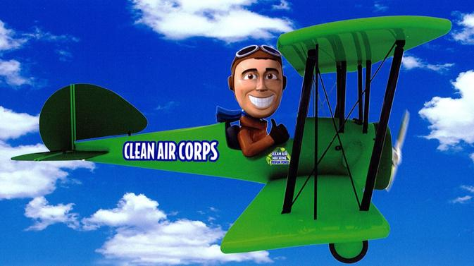
MS Gulf Coast Clean Air Campaign
No-Idling Program Fact Sheet

Program Participants:
The intended participants in the No-Idling program are schools, community groups, clubs, faith-based organizations and other citizen based groups whose guests, members or others often idling for significant periods of time at their activities or on their campuses.

Program Length:
To complete the initial installation of the No-Idling program it will take between 2 and 3 months depending on your schedule and participation level.

Program Outline:

Phase I: Planning
Using the MS Gulf Coast manual and working with the Clean Air Campaign Coordinator, develop a plan for your organization that identifies activities to be completed, participants, locations, schedules, budget/costs, etc.
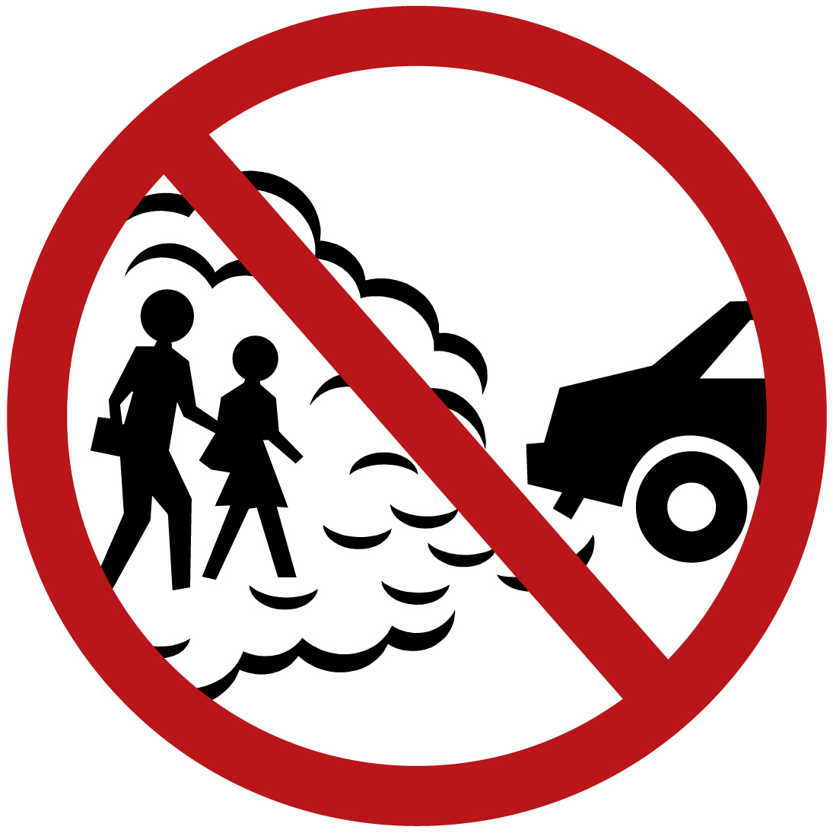

Phase II: Research
Conduct activities that will result in gathering your baseline statistics

Phase III: Education
In the school there are several groups to educate including: parents, teachers and staff, bus and delivery drivers, the students and the surrounding community.

Phase IV: Follow-up research
Conduct identical follow-up studies to collect data on improvement directly following the educational activities and again on month after active awareness and outreach ends. This will give you your true improvement result

Phase V: Reporting
Complete a self-assessment compiling lessons learned from conducting the program. What will work better next year? What continuing activities will be completed and by whom? Supply compiled results to Clean Air Coordinator for EPA submission, MDEQ submission, local media submission and Coastcleanair.org spotlight articles.

The No-Idling Program can be completed individually or be partnered with other Clean Air activities. The two most common partnering activities are asthma awareness and the air quality flag program.

